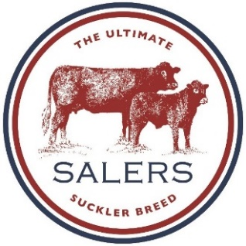
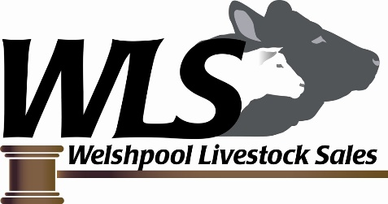

Welshpool Livestock Services
Buttington Cross, Buttington, Welshpool, Powys, SY21 8SR
Telephone : 01938 553438
Email: welshpool@auctionmarts.com
Salers Cattle Society of the UK Ltd
Jasmine Cottage, 2 Maitland Row
Gavinton, TD11 3QP
Telephone: 07903 626 249
Email: secretary@salers.uk

AUTUMN SALE OF
PEDIGREE & COMMERCIAL CATTLE
(Held under the auspices of the Salers Cattle Society of the UK Ltd)

SATURDAY 9th OCTOBER 2021
INSPECTION – 7am to 8am
SHOW – 9am
SALE – 11am
Entries to be returned with accompanying certificates to:

Welshpool Livestock Sales, Buttington Cross, Buttingham, Welshpool, Powys, SY21 8SR
E: welshpool@auctionmarts.com
01938 553438

Entry deadline: Friday 27th August 2021

This sale is restricted to members of, and to cattle correctly registered with, the Salers Cattle Society of the UK.

Pedigree & Commercial Salers Cattle:
- Entry fee of £50+VAT for all pedigree cattle (Fullblood and Purebred). £40+VAT of which will be refundable on sale of animal or presentation of veterinary certificate. Cheques to be made payable to Welshpool Livestock Market.
- Commercial cattle will not be charged an entry fee and must be clearly labelled commercial on the entry form.
- Pedigree cattle to be sold in guineas.
- Pedigree cattle to be sold in guineas. The commission on pedigree sales will be the guinea to the auctioneers and 2% to Salers Society.
- The commission on commercial cattle will be: 3.1% - auctioneers and 1% - Salers society
- All pedigree cattle must be halter trained and wear nose leaders
- All pedigree cattle will be inspected at the market by a veterinary surgeon, and by a Society approved inspector; cattle will be paraded for this inspection. Commercial cattle will be inspected in their pens by a Society Inspector
- Pedigree cattle must have non-carrier status for beta mannosidosis either by DNA test or by parentage
- All cattle must comply with Salers Cattle Society of the UK rules regarding Herd Health.

DNA & MYOSTATIN STATUS
All pedigree bulls must have a DNA profile and have been tested for myostatin, the result will be made visible in the catalogue. All females for sale at society sales, including production Salers but not commercial animals, are to be tested for myostatin, unless they have a myostatin status of M0P (Myostatin free by Parentage) again the results will be visible in the sale catalogue.

Please Note:
- Any cattle deemed not to standard will be rejected and must be removed from the premises prior to the sale
- Any animal showing signs of bad temperament will be rejected (Society’s decision is final)
- Weights and scrotal sizes should be within the Society Guidelines (see attached)
- All vendors must comply with all legal movement requirements
- All cattle must comply with pre-movement TB testing regulations. All entrants must disclose TB testing time
- The official registration certificate issued by the society must accompany the entry form and entry fee along with the enclosed herd health declaration.
- An A.I. certificate must accompany the entry forms for any cows or heifers being sold described as in-calf by A.I.
- Entries for recipients with pedigree calves at foot are also invited.
- A cow and calf may be allocated:-
  - One lot number therefore sold together as one consignment (single entry fee), or
  - Individual lot numbers therefore sold separately, providing the calf was born before 1st January 2021 (double entry fee)
- It must be stated, if any cows entered, have been flushed and how many embryos have been taken.
- In the case of bulls, it must be stated if any semen has been retained and if so how many straws.

TB testing:
- All cattle over 42 days of age, from 1 and 2 year testing areas, will need to have been TB tested within the last 60 days prior to the sale date.
- Pre-movement TB testing is compulsory in 1 and 2 year testing areas.
- It is the responsibility of the vendor to check with the auctioneers prior to the sale, what is required. No cattle can be accepted for the sale unless official documentation regarding TB accompanies the entry form.

Johnes:
All cattle entered and presented at this sale must be from vendors who are members of a CHeCS Herd Scheme, and who comply with the current Salers Society ruling for BVD FREE SALES, and have established their JOHNES herd status and are actively monitoring and culling diseased animals from the herd. Only level 1 – 4 status are permitted at Society sales. Please note that the Johnes test results act only as an indicator for the herd at the time the test is carried out. In no way is it offered or implied as a guarantee of freedom from Johnes.

BVD:
All cattle for sale must be from a BVD CHeCS accredited herd or have been individually tested BVD Antigen negative. All such animals MUST be fully vaccinated at least two weeks prior to the sale. Females that are sold in-calf or running with the bull must be from a BVD accredited herd or individually tested BEFORE service, with the BVD status of the bull being determined BEFORE he serves any females that are to be sold.

ALL DATES OF VACCINATIONS MUST BE GIVEN TO THE MART OFFICE
IF ENTERING CATTLE NOT BELONGING TO YOUR HERD THE CURRENT HEALTH STATUS OF THOSE CATTLE MUST BE DECLARED
FAILURE TO COMPLY WITH THE ANY OF THE ABOVE WILL RESULT IN ANIMALS BEING REJECTED FROM THE SALE!!

If in doubt, regarding the cattle you wish to enter, please contact the Society Secretary (Sian Sharp; 07903 626249) to arrange a preliminary on farm inspection. This however, does not guarantee the animals will be passed on the sale day.

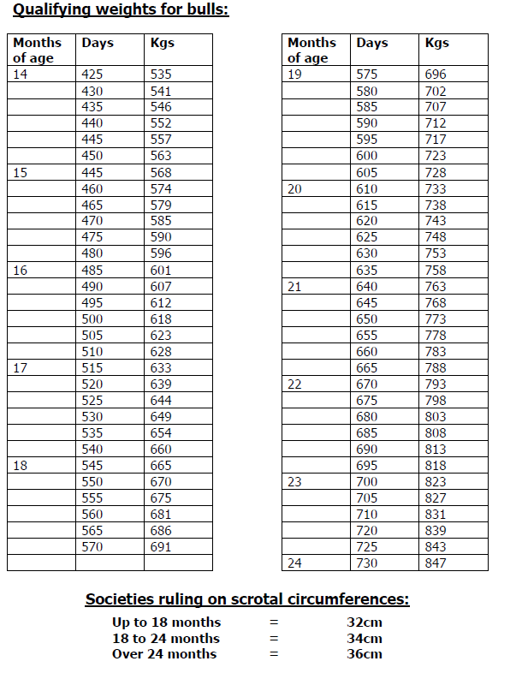

HOLDING LETTER: …………………………………………………… HERD PREFIX……………….

NAME:……………………………………………………………………………………………………….

ADDDRESS: ……………………………………………………………………………………………….

TEL NO: ………………………………………………………………….. SALE DATE: ……………….

BOVINE TB
DATE HERD LAST TESTED CLEAR: |  |  | TESTING INTERVAL: □ 1YEAR □ 3YEARS  □ 2YEARS □ 4 YEARS

HEALTH SCHEME
PLEASE INDICATE WHICH HEALTH SCHEME YOU ARE A MEMBER OF
□ SAC Premium Cattle Health Scheme □ Biobest Hi Health Herdcare □ NML Herdwise
□ NWL Advance Cattle Health Scheme □ AFBI Cattle Health Scheme □ Other (please name)…………..
TICK WHICH DISEASES APPLY: □ JOHNES □ BVD □ IBR □ LEPTO

ALL VENDORS MUST COMPLETE THE FOLLOWING
 | Accredited free  (CHeCS members only) | Herd Testing |  | Vaccination of Sale Animals Only
BVD | □ Yes  □ No  if yes, since: | □ Yes  □ No  If yes, since: |  | □ Yes Vaccine – Bovidec/Bovilis  (delete as applicable)
IBR | □ Yes  □ No  if yes, since: | □ Yes  □ No  if yes, since: |  | □ Yes If Yes, name of Vaccine:  □ No
LEPTO | □ Yes  □ No  if yes, since: | □ Yes  □ No  if yes, since: |  | □ Yes If Yes, name of Vaccine:  □ No
JOHNES | Risk Level  (Consult your health scheme)  Risk Level 1 □ Accredited  Risk Level 2 □  Risk Level 3 □  Risk Level 4 □ | Number of Consecutive Years Monitored Clear  (Consult your Health Scheme)  Years |  | □ Yes If Yes, name of Vaccine:  □ No

VENDOR DECLARATION:
I certify that the above information is correct at date of entry. The animal/s have been individually screened for BVD virus,
to identify PI’s (only applicable if not BVD Accredited) and my herd is Johnes monitored risk level 1-4.
I attach a copy of veterinary certificate results.
All sale animals entered are BVD vaccinated and from a Johnes monitored herd risk level 1-4.
I allow the Breed Society/Auctioneer to verify the details above with my CHeCHS Health Scheme Provider if applicable:

Signed: ____________________________________ Name: _________________________ Date:_____________

Disclaimer: The above information is supplied by the vendor and the Auctioneer/Breed Society is not responsible for the accuracy of this information
Failure to complete and return this declaration with the entries may result in the animals not being accepted for the sale.

